Latest Updates In Online

Quality Effected Habs Entry Form has been added which can be accessed from menu as

Maseters -> Quality Effected Habs

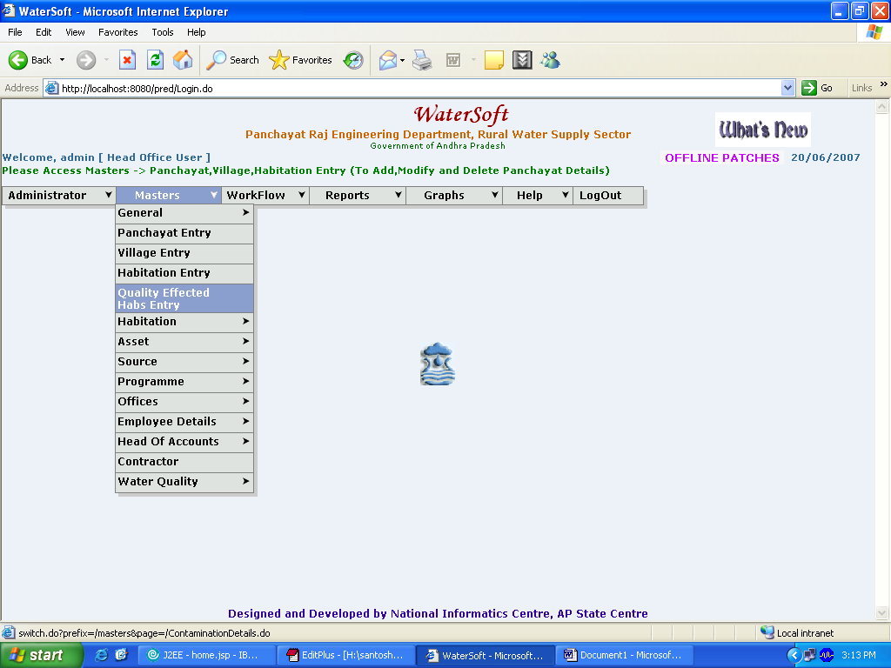

By Using this form contamination Details for Quality Effected Habs(NSS) can be entered.

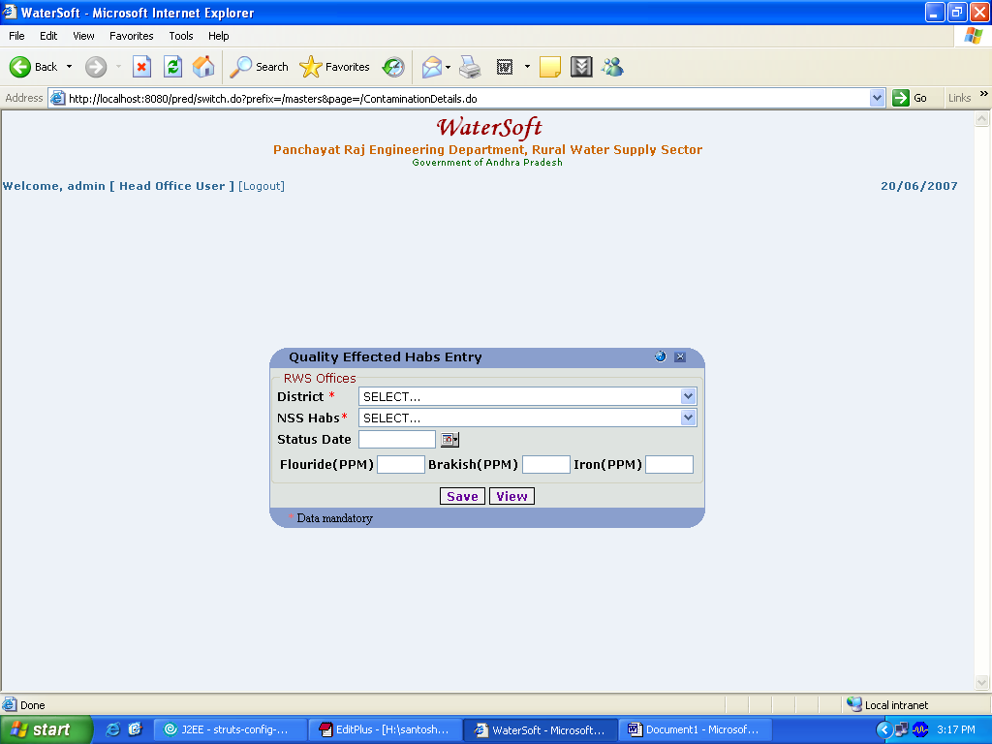

Select District and Habitation to get the Contamination Details for that habitation. Enter the Contamination Details and Click on Save to save the Contamination Details.

You can also click on View to get Contamination Details of the Habitations of the entire district.

